

**Pre-Lab 4a**

Name: Socheath Sok,

Class: EE 346 L

Section 6, T/Th

Date: October 9, 2018

**Questions:**

1. What values would need to be loaded into TCNT1H and TCNT1L to generate

a 455 ms delay at our clock frequency of 20.000 MHz and a prescale divisor of 256 (show

your work)?

$t{}_{clk }= \frac{256}{20 MHz}=12.8 μs$

$tic = \frac{455 ms}{12.8 us/tic}=35547 tics$

$△ = max tic - tic = 2^{16}-35547 =29989 tics ==> 0x7525$

TCNT1H = 0x75 and TCNT1L = 0x25

2. The first two lines of code set both CS11 and CS10 bits to 1 in Timer 1 register TCCR1B,

while setting all other bits to zero. What hexadecimal value is saved in TCCR1B?

TCCR1B = 0x03

3. Write a small assembly subroutine named delay to poll the TOVF1 flag. When the flag is set

(TOV1 = 1), clear theTOV1 flag by writing a 1 (sbi TIFR1, TOV1), and reset the timer value

(TCNT1H:TCNT1L = 0x0BDC).

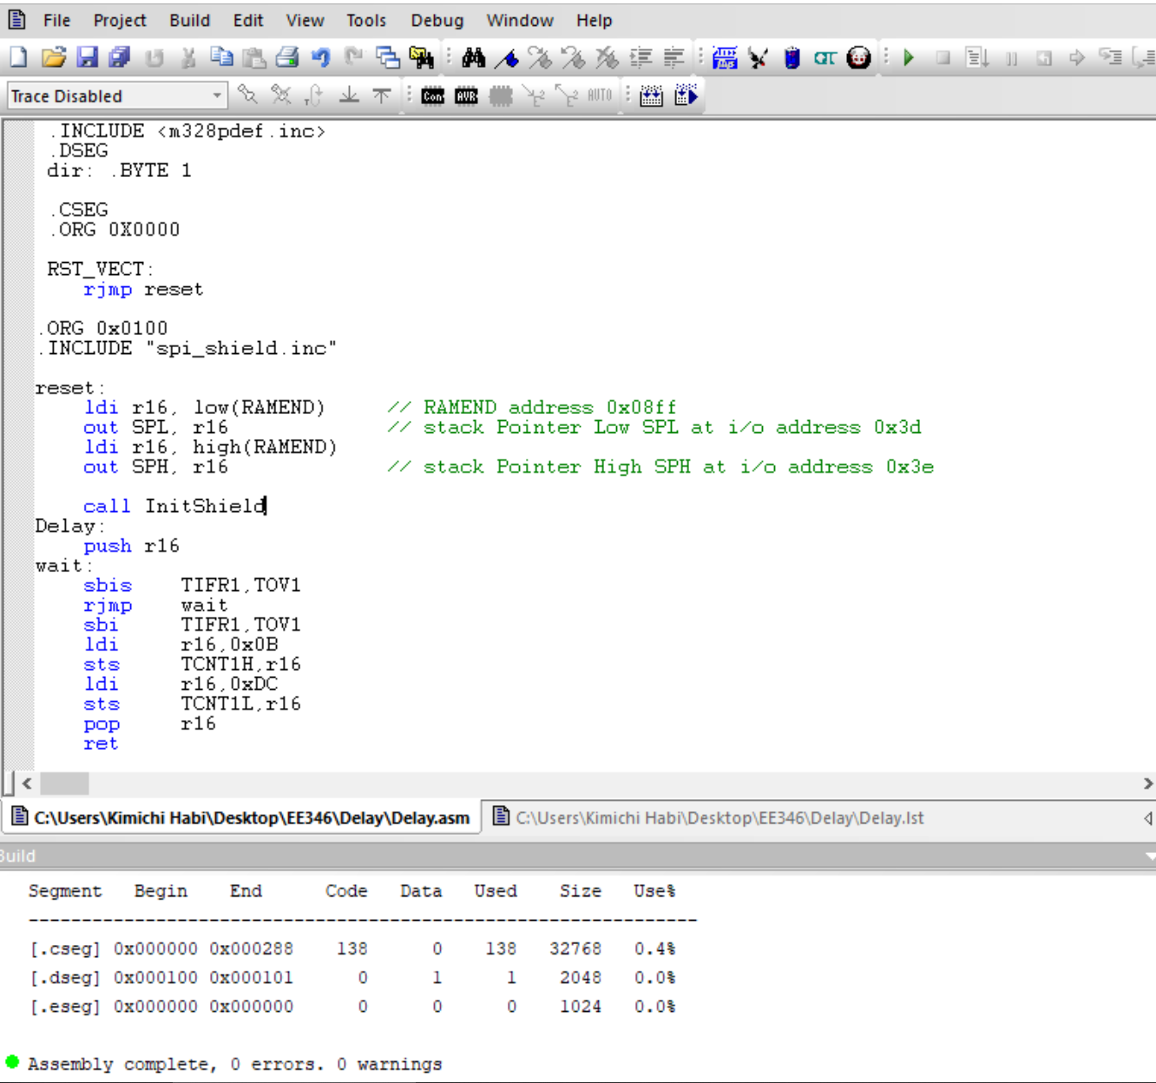

4. Complete the code

; — 250 msec —-  
rcall Delay  
; — next_state —  
lds r20, next_state // toggle next_state  
ldi r16, 0x 11   
eor r20, r16   
sts next_state, r20

5. In this lab you will be generating a 2-state FSM. You have now written a subroutine to

generate a delay of 250 ms and can toggle variable next_state at a frequency of 2 Hz, but

how will you know it really works? Write a short program 4 to 5 line program to move bits 1

and 0 in register r20, to discrete LEDs (spiLEDS) bits 7 and 6.

Implementing the program will determine whether the code is written correctly or not.

**bst** r20,1

**bld** spiLEDS,7

**bst** r20,0

**bld**spiLEDs, 6

**call** WriteDisplay